
Photo By: Michal Robak
This photo shows a shallow depth of field, which is when the camera is focused on one object and the rest of the background is out of focus. In this image the branch with the berries is in focus and the background with the rocks and other trees is out of focus.

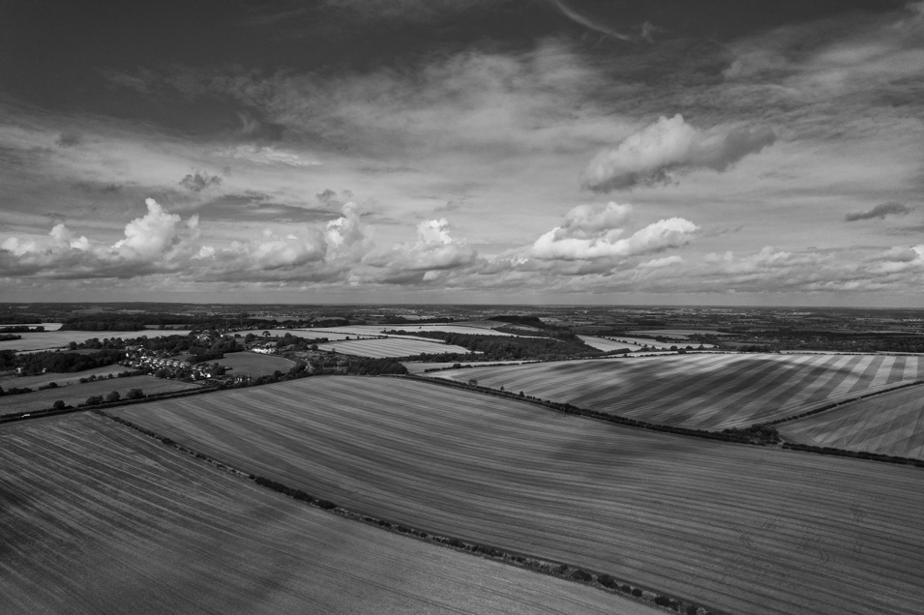
Photo By: Altaf Shah
This photo shows a large depth of field, which is when everything in the foreground and background is in focus. This image is a good example of that because even though everything is far away everything in the photo is in focus and as clear as possible.
I think both of these images are great and do a good job of showing the versatility of photography.

